Initial Values
Epoch 1/10, Train loss: 2.2109, Train acc: 20.04%, Val acc: 25.30%
Epoch 2/10, Train loss: 2.0898, Train acc: 27.84%, Val acc: 29.30%
Epoch 3/10, Train loss: 2.0293, Train acc: 30.47%, Val acc: 31.54%
Epoch 4/10, Train loss: 1.9910, Train acc: 31.88%, Val acc: 32.42%
Epoch 5/10, Train loss: 1.9634, Train acc: 32.92%, Val acc: 33.14%
Epoch 6/10, Train loss: 1.9423, Train acc: 33.72%, Val acc: 33.06%
Epoch 7/10, Train loss: 1.9257, Train acc: 34.31%, Val acc: 34.38%
Epoch 8/10, Train loss: 1.9116, Train acc: 34.76%, Val acc: 34.86%
Epoch 9/10, Train loss: 1.8999, Train acc: 35.15%, Val acc: 35.16%
batch size 64
findings: validation score went up train accuracy/loss stayed about the same
Epoch 1/10, Train loss: 2.2047, Train acc: 21.30%, Val acc: 27.56%
Epoch 2/10, Train loss: 2.0897, Train acc: 27.80%, Val acc: 29.88%
Epoch 3/10, Train loss: 2.0310, Train acc: 30.15%, Val acc: 32.16%
Epoch 4/10, Train loss: 1.9933, Train acc: 31.60%, Val acc: 33.42%
Epoch 5/10, Train loss: 1.9657, Train acc: 32.62%, Val acc: 33.88%
Epoch 6/10, Train loss: 1.9448, Train acc: 33.43%, Val acc: 35.58%
Epoch 7/10, Train loss: 1.9282, Train acc: 34.03%, Val acc: 36.34%
Epoch 8/10, Train loss: 1.9141, Train acc: 34.41%, Val acc: 35.70%
Epoch 9/10, Train loss: 1.9024, Train acc: 34.64%, Val acc: 36.70%
Epoch 10/10, Train loss: 1.8922, Train acc: 35.10%, Val acc: 36.88%
batch size 256, all values decreased and train loss increased
Epoch 1/10, Train loss: 2.2343, Train acc: 18.05%, Val acc: 23.46%
Epoch 2/10, Train loss: 2.1531, Train acc: 25.05%, Val acc: 27.72%
Epoch 3/10, Train loss: 2.1008, Train acc: 27.73%, Val acc: 29.20%
Epoch 4/10, Train loss: 2.0637, Train acc: 29.31%, Val acc: 30.26%
Epoch 5/10, Train loss: 2.0358, Train acc: 30.48%, Val acc: 29.58%
Epoch 6/10, Train loss: 2.0136, Train acc: 31.29%, Val acc: 31.50%
Epoch 7/10, Train loss: 1.9950, Train acc: 31.97%, Val acc: 32.04%
Epoch 8/10, Train loss: 1.9799, Train acc: 32.49%, Val acc: 33.16%
Epoch 9/10, Train loss: 1.9669, Train acc: 32.91%, Val acc: 33.62%
Epoch 10/10, Train loss: 1.9551, Train acc: 33.40%, Val acc: 33.72%

batch size 64 learning rate = 1e-5 weight decay = 1e-2
findings: everything got worse
Epoch 1/10, Train loss: 2.3130, Train acc: 7.69%, Val acc: 8.82%
Epoch 2/10, Train loss: 2.3015, Train acc: 9.99%, Val acc: 11.58%
Epoch 3/10, Train loss: 2.2939, Train acc: 12.58%, Val acc: 13.84%
Epoch 4/10, Train loss: 2.2878, Train acc: 14.00%, Val acc: 14.88%
Epoch 5/10, Train loss: 2.2822, Train acc: 14.67%, Val acc: 15.58%
Epoch 6/10, Train loss: 2.2770, Train acc: 15.14%, Val acc: 16.22%
Epoch 7/10, Train loss: 2.2719, Train acc: 15.58%, Val acc: 16.66%
Epoch 8/10, Train loss: 2.2669, Train acc: 16.04%, Val acc: 17.12%
Epoch 9/10, Train loss: 2.2621, Train acc: 16.38%, Val acc: 17.50%
Epoch 10/10, Train loss: 2.2574, Train acc: 16.79%, Val acc: 18.20%
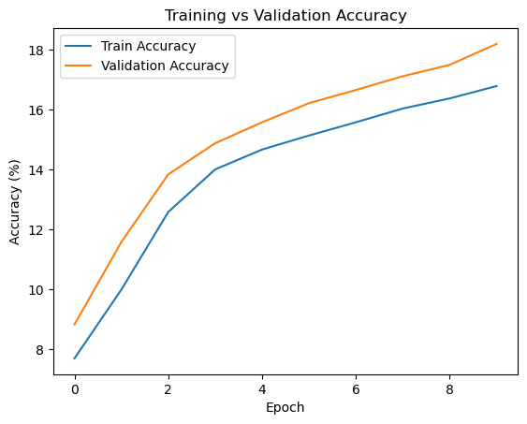

changed learning rate = 1e-2 weight decay = 1e-5
findings: all values got better but the Val accuracy was not the highest recorded
Epoch 1/10, Train loss: 1.9596, Train acc: 29.95%, Val acc: 23.24%
Epoch 2/10, Train loss: 1.8445, Train acc: 35.39%, Val acc: 27.32%
Epoch 3/10, Train loss: 1.8129, Train acc: 36.78%, Val acc: 31.52%
Epoch 4/10, Train loss: 1.7946, Train acc: 37.47%, Val acc: 32.70%
Epoch 5/10, Train loss: 1.7792, Train acc: 38.43%, Val acc: 28.44%
Epoch 6/10, Train loss: 1.7692, Train acc: 38.64%, Val acc: 30.44%
Epoch 7/10, Train loss: 1.7598, Train acc: 39.13%, Val acc: 32.94%
Epoch 8/10, Train loss: 1.7535, Train acc: 39.34%, Val acc: 30.18%
Epoch 9/10, Train loss: 1.7457, Train acc: 39.90%, Val acc: 33.42%
Epoch 10/10, Train loss: 1.7396, Train acc: 39.73%, Val acc: 34.02%
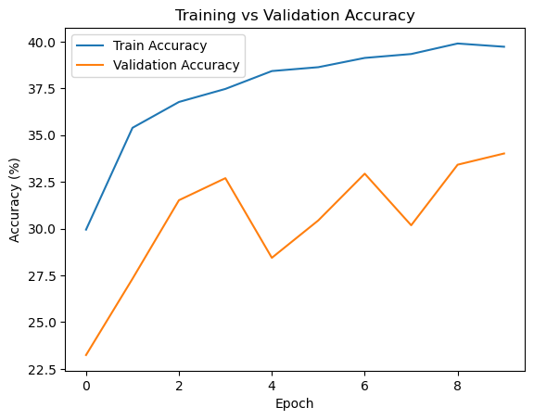
Batch size 64 learning_rate = 1e-2 weight_decay = 1e-7
Findings: most values stayed the same but the val acc went up overall but was inconsistent
Epoch 1/10, Train loss: 1.9603, Train acc: 30.29%, Val acc: 15.22%
Epoch 2/10, Train loss: 1.8478, Train acc: 35.20%, Val acc: 31.94%
Epoch 3/10, Train loss: 1.8148, Train acc: 36.82%, Val acc: 29.90%
Epoch 4/10, Train loss: 1.7947, Train acc: 37.49%, Val acc: 34.02%
Epoch 5/10, Train loss: 1.7788, Train acc: 38.25%, Val acc: 34.86%
Epoch 6/10, Train loss: 1.7688, Train acc: 38.60%, Val acc: 25.40%
Epoch 7/10, Train loss: 1.7601, Train acc: 39.05%, Val acc: 25.96%
Epoch 8/10, Train loss: 1.7534, Train acc: 39.07%, Val acc: 24.64%
Epoch 9/10, Train loss: 1.7487, Train acc: 39.39%, Val acc: 32.44%
Epoch 10/10, Train loss: 1.7404, Train acc: 39.67%, Val acc: 17.86%
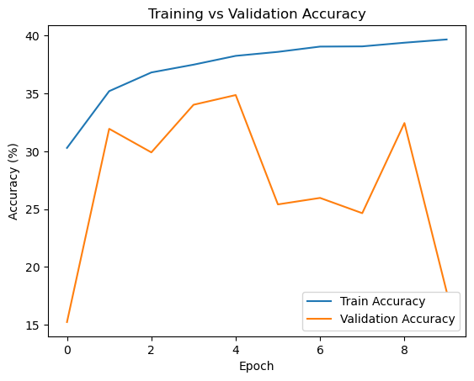
weight_decay = 1e-2
findings: validation accuracy higher then 1e-5 and is more consistent then 1e-7, train acc about the same
Epoch 1/10, Train loss: 1.9610, Train acc: 29.86%, Val acc: 22.94%
Epoch 2/10, Train loss: 1.8500, Train acc: 35.16%, Val acc: 30.96%
Epoch 3/10, Train loss: 1.8181, Train acc: 36.40%, Val acc: 32.88%
Epoch 4/10, Train loss: 1.8019, Train acc: 37.36%, Val acc: 31.90%
Epoch 5/10, Train loss: 1.7904, Train acc: 37.60%, Val acc: 28.24%
Epoch 6/10, Train loss: 1.7822, Train acc: 37.98%, Val acc: 22.74%
Epoch 7/10, Train loss: 1.7758, Train acc: 38.16%, Val acc: 32.96%
Epoch 8/10, Train loss: 1.7723, Train acc: 38.43%, Val acc: 33.12%
Epoch 9/10, Train loss: 1.7643, Train acc: 38.61%, Val acc: 33.56%
Epoch 10/10, Train loss: 1.7599, Train acc: 39.02%, Val acc: 35.06%
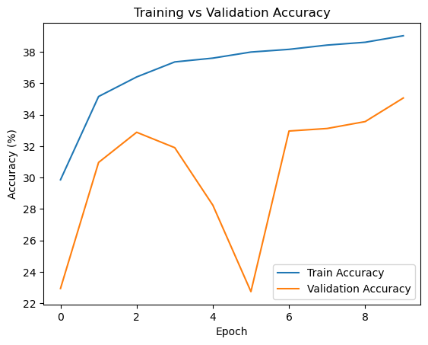
Batch size 128 learning_rate = 1e-2 weight_decay = 1e-2
Findings: train acc very slightly down but val acc is up and consistent
Epoch 1/10, Train loss: 2.0082, Train acc: 28.89%, Val acc: 31.64%
Epoch 2/10, Train loss: 1.8768, Train acc: 34.63%, Val acc: 33.18%
Epoch 3/10, Train loss: 1.8386, Train acc: 36.26%, Val acc: 34.32%
Epoch 4/10, Train loss: 1.8194, Train acc: 37.00%, Val acc: 36.36%
Epoch 5/10, Train loss: 1.8040, Train acc: 37.62%, Val acc: 36.34%
Epoch 6/10, Train loss: 1.7952, Train acc: 37.95%, Val acc: 36.46%
Epoch 7/10, Train loss: 1.7864, Train acc: 38.34%, Val acc: 35.32%
Epoch 8/10, Train loss: 1.7804, Train acc: 38.33%, Val acc: 37.40%
Epoch 9/10, Train loss: 1.7736, Train acc: 38.86%, Val acc: 34.28%
Epoch 10/10, Train loss: 1.7697, Train acc: 38.97%, Val acc: 37.10%
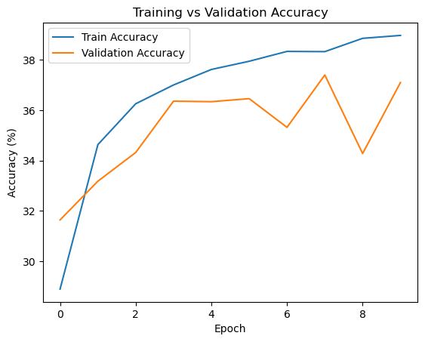

Chosen params: Batch size 128 learning_rate = 1e-2 weight_decay = 1e-2
Epoch 1/10, Train loss: 2.0041, Train acc: 28.82%, Val acc: 26.82%
Epoch 2/10, Train loss: 1.8746, Train acc: 34.83%, Val acc: 33.40%
Epoch 3/10, Train loss: 1.8394, Train acc: 36.13%, Val acc: 36.02%
Epoch 4/10, Train loss: 1.8174, Train acc: 36.87%, Val acc: 36.98%
Epoch 5/10, Train loss: 1.8037, Train acc: 37.46%, Val acc: 37.90%
Epoch 6/10, Train loss: 1.7942, Train acc: 37.81%, Val acc: 36.40%
Epoch 7/10, Train loss: 1.7847, Train acc: 38.52%, Val acc: 35.60%
Epoch 8/10, Train loss: 1.7778, Train acc: 38.64%, Val acc: 38.84%
Epoch 9/10, Train loss: 1.7719, Train acc: 38.99%, Val acc: 33.76%
Epoch 10/10, Train loss: 1.7693, Train acc: 39.04%, Val acc: 36.52%
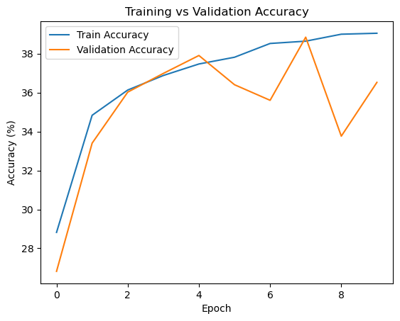

Retraining on train + validation...

Final Test Accuracy: 37.91% pretty good for linear classifier
2 layer
Basic inputs
Findings: all values were better in the linear classifier at default values
Epoch 1/10, Train loss: 2.2845, Train acc: 12.24%, Val acc: 15.16%
Epoch 2/10, Train loss: 2.2457, Train acc: 18.81%, Val acc: 23.40%
Epoch 3/10, Train loss: 2.2064, Train acc: 23.61%, Val acc: 25.02%
Epoch 4/10, Train loss: 2.1660, Train acc: 25.58%, Val acc: 27.38%
Epoch 5/10, Train loss: 2.1275, Train acc: 27.29%, Val acc: 27.32%
Epoch 6/10, Train loss: 2.0934, Train acc: 27.94%, Val acc: 29.70%
Epoch 7/10, Train loss: 2.0640, Train acc: 29.11%, Val acc: 30.46%
Epoch 8/10, Train loss: 2.0388, Train acc: 30.02%, Val acc: 30.98%
Epoch 9/10, Train loss: 2.0171, Train acc: 30.72%, Val acc: 31.10%
Epoch 10/10, Train loss: 1.9984, Train acc: 31.19%, Val acc: 31.94%
Using my chosen hyperparams from linear classifier
Findings: all values got better then default values and surpassed the linear classifier
Epoch 1/10, Train loss: 2.1235, Train acc: 25.09%, Val acc: 29.34%
Epoch 2/10, Train loss: 1.9461, Train acc: 31.92%, Val acc: 32.66%
Epoch 3/10, Train loss: 1.8833, Train acc: 34.33%, Val acc: 35.62%
Epoch 4/10, Train loss: 1.8448, Train acc: 35.64%, Val acc: 36.90%
Epoch 5/10, Train loss: 1.8159, Train acc: 36.72%, Val acc: 37.46%
Epoch 6/10, Train loss: 1.7907, Train acc: 37.68%, Val acc: 37.78%
Epoch 7/10, Train loss: 1.7689, Train acc: 38.56%, Val acc: 38.40%
Epoch 8/10, Train loss: 1.7505, Train acc: 39.11%, Val acc: 38.32%
Epoch 9/10, Train loss: 1.7340, Train acc: 39.69%, Val acc: 40.26%
Epoch 10/10, Train loss: 1.7180, Train acc: 40.18%, Val acc: 40.62%
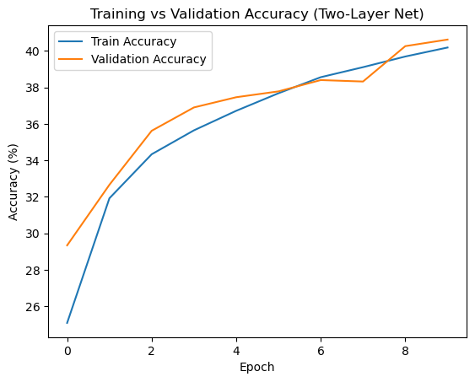

Hidden dim 50
Findings: not much change but slight loss of values
Epoch 1/10, Train loss: 2.1372, Train acc: 23.94%, Val acc: 30.90%
Epoch 2/10, Train loss: 1.9512, Train acc: 31.66%, Val acc: 33.02%
Epoch 3/10, Train loss: 1.8876, Train acc: 34.13%, Val acc: 34.68%
Epoch 4/10, Train loss: 1.8494, Train acc: 35.41%, Val acc: 35.90%
Epoch 5/10, Train loss: 1.8209, Train acc: 36.46%, Val acc: 35.96%
Epoch 6/10, Train loss: 1.7979, Train acc: 37.42%, Val acc: 37.06%
Epoch 7/10, Train loss: 1.7780, Train acc: 38.14%, Val acc: 37.66%
Epoch 8/10, Train loss: 1.7606, Train acc: 38.76%, Val acc: 38.74%
Epoch 9/10, Train loss: 1.7443, Train acc: 39.26%, Val acc: 38.28%
Epoch 10/10, Train loss: 1.7302, Train acc: 39.92%, Val acc: 38.92%
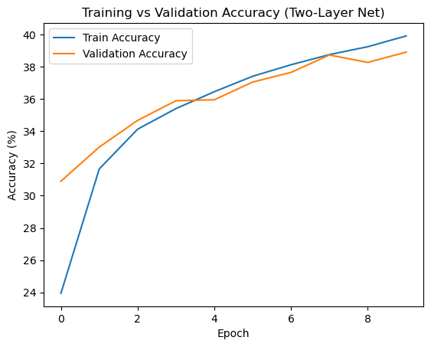
Hidden dim 200
Findings:nothing changed
Hidden dim 150 epochs 15
Findings: all values got better slightly
hidden_dim = 150 learning_rate = 1e-2 weight_decay = 1e-3 num_epochs = 25
findings: all values continue to go up
Epoch 1/25, Train loss: 2.1240, Train acc: 25.23%, Val acc: 31.48%
Epoch 2/25, Train loss: 1.9360, Train acc: 32.54%, Val acc: 32.86%
Epoch 3/25, Train loss: 1.8716, Train acc: 34.72%, Val acc: 35.06%
Epoch 4/25, Train loss: 1.8306, Train acc: 36.12%, Val acc: 35.78%
Epoch 5/25, Train loss: 1.7968, Train acc: 37.09%, Val acc: 37.18%
Epoch 6/25, Train loss: 1.7685, Train acc: 38.18%, Val acc: 38.26%
Epoch 7/25, Train loss: 1.7436, Train acc: 39.17%, Val acc: 38.10%
Epoch 8/25, Train loss: 1.7206, Train acc: 39.98%, Val acc: 40.10%
Epoch 9/25, Train loss: 1.7013, Train acc: 40.61%, Val acc: 40.86%
Epoch 10/25, Train loss: 1.6816, Train acc: 41.34%, Val acc: 41.36%
Epoch 11/25, Train loss: 1.6644, Train acc: 41.85%, Val acc: 41.40%
Epoch 12/25, Train loss: 1.6482, Train acc: 42.54%, Val acc: 42.32%
Epoch 13/25, Train loss: 1.6328, Train acc: 43.13%, Val acc: 42.84%
Epoch 14/25, Train loss: 1.6174, Train acc: 43.50%, Val acc: 42.30%
Epoch 15/25, Train loss: 1.6043, Train acc: 44.18%, Val acc: 43.36%
Epoch 16/25, Train loss: 1.5913, Train acc: 44.54%, Val acc: 43.40%
Epoch 17/25, Train loss: 1.5798, Train acc: 45.04%, Val acc: 44.74%
Epoch 18/25, Train loss: 1.5689, Train acc: 45.28%, Val acc: 44.62%
Epoch 19/25, Train loss: 1.5581, Train acc: 45.79%, Val acc: 44.96%
Epoch 20/25, Train loss: 1.5483, Train acc: 46.13%, Val acc: 45.12%
Epoch 21/25, Train loss: 1.5381, Train acc: 46.65%, Val acc: 46.04%
Epoch 22/25, Train loss: 1.5296, Train acc: 46.68%, Val acc: 46.12%
Epoch 23/25, Train loss: 1.5209, Train acc: 47.15%, Val acc: 45.88%
Epoch 24/25, Train loss: 1.5124, Train acc: 47.34%, Val acc: 45.62%
Epoch 25/25, Train loss: 1.5049, Train acc: 47.66%, Val acc: 45.00%
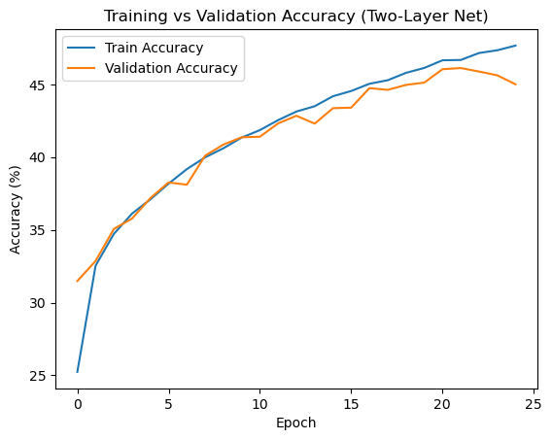
hidden_dim = 300 learning_rate = 1e-2 weight_decay = 1e-3 num_epochs = 40
values gone up all by about the same rate
Epoch 1/40, Train loss: 2.1098, Train acc: 25.06%, Val acc: 30.42%
Epoch 2/40, Train loss: 1.9333, Train acc: 32.46%, Val acc: 33.82%
Epoch 3/40, Train loss: 1.8673, Train acc: 34.72%, Val acc: 35.48%
Epoch 4/40, Train loss: 1.8249, Train acc: 36.29%, Val acc: 36.10%
Epoch 5/40, Train loss: 1.7900, Train acc: 37.66%, Val acc: 37.08%
Epoch 6/40, Train loss: 1.7601, Train acc: 38.84%, Val acc: 38.56%
Epoch 7/40, Train loss: 1.7350, Train acc: 39.59%, Val acc: 39.60%
Epoch 8/40, Train loss: 1.7112, Train acc: 40.58%, Val acc: 40.04%
Epoch 9/40, Train loss: 1.6919, Train acc: 40.97%, Val acc: 41.18%
Epoch 10/40, Train loss: 1.6724, Train acc: 41.73%, Val acc: 41.16%
Epoch 11/40, Train loss: 1.6537, Train acc: 42.37%, Val acc: 41.84%
Epoch 12/40, Train loss: 1.6363, Train acc: 42.88%, Val acc: 43.06%
Epoch 13/40, Train loss: 1.6200, Train acc: 43.65%, Val acc: 42.34%
Epoch 14/40, Train loss: 1.6056, Train acc: 44.20%, Val acc: 43.16%
Epoch 15/40, Train loss: 1.5905, Train acc: 44.63%, Val acc: 43.48%
Epoch 16/40, Train loss: 1.5775, Train acc: 45.23%, Val acc: 43.80%
Epoch 17/40, Train loss: 1.5656, Train acc: 45.69%, Val acc: 44.96%
Epoch 18/40, Train loss: 1.5539, Train acc: 45.95%, Val acc: 45.02%
Epoch 19/40, Train loss: 1.5437, Train acc: 46.39%, Val acc: 44.50%
Epoch 20/40, Train loss: 1.5325, Train acc: 46.85%, Val acc: 46.22%
Epoch 21/40, Train loss: 1.5246, Train acc: 47.06%, Val acc: 44.96%
Epoch 22/40, Train loss: 1.5127, Train acc: 47.34%, Val acc: 45.58%
Epoch 23/40, Train loss: 1.5051, Train acc: 47.61%, Val acc: 46.66%
Epoch 24/40, Train loss: 1.4957, Train acc: 47.86%, Val acc: 47.02%
Epoch 25/40, Train loss: 1.4883, Train acc: 48.33%, Val acc: 45.64%
Epoch 26/40, Train loss: 1.4793, Train acc: 48.61%, Val acc: 47.32%
Epoch 27/40, Train loss: 1.4696, Train acc: 48.93%, Val acc: 47.54%
Epoch 28/40, Train loss: 1.4634, Train acc: 48.95%, Val acc: 47.72%
Epoch 29/40, Train loss: 1.4564, Train acc: 49.46%, Val acc: 46.08%
Epoch 30/40, Train loss: 1.4468, Train acc: 49.75%, Val acc: 47.36%
Epoch 31/40, Train loss: 1.4419, Train acc: 49.90%, Val acc: 47.96%
Epoch 32/40, Train loss: 1.4346, Train acc: 50.08%, Val acc: 48.08%
Epoch 33/40, Train loss: 1.4277, Train acc: 50.48%, Val acc: 48.48%
Epoch 34/40, Train loss: 1.4198, Train acc: 50.58%, Val acc: 47.28%
Epoch 35/40, Train loss: 1.4141, Train acc: 50.91%, Val acc: 48.96%
Epoch 36/40, Train loss: 1.4083, Train acc: 51.12%, Val acc: 48.80%
Epoch 37/40, Train loss: 1.4024, Train acc: 51.33%, Val acc: 49.82%
Epoch 38/40, Train loss: 1.3962, Train acc: 51.49%, Val acc: 49.28%
Epoch 39/40, Train loss: 1.3883, Train acc: 51.68%, Val acc: 49.44%
Epoch 40/40, Train loss: 1.3832, Train acc: 51.83%, Val acc: 49.86%
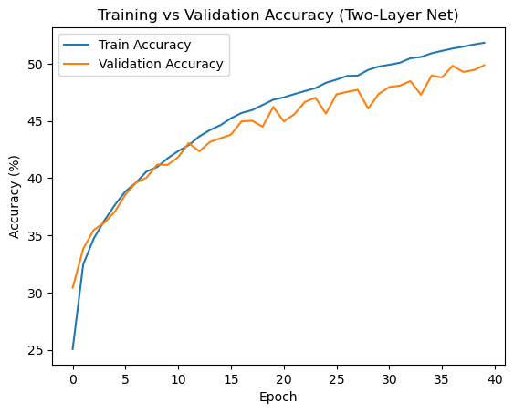
Upping to 50 epochs and testing
Epoch 1/50, Train loss: 2.1085, Train acc: 26.03%, Val acc: 32.12%
Epoch 2/50, Train loss: 1.9285, Train acc: 32.64%, Val acc: 33.80%
Epoch 3/50, Train loss: 1.8618, Train acc: 35.24%, Val acc: 35.44%
Epoch 4/50, Train loss: 1.8187, Train acc: 36.65%, Val acc: 37.24%
Epoch 5/50, Train loss: 1.7861, Train acc: 37.80%, Val acc: 37.82%
Epoch 6/50, Train loss: 1.7582, Train acc: 38.73%, Val acc: 37.56%
Epoch 7/50, Train loss: 1.7331, Train acc: 39.86%, Val acc: 39.84%
Epoch 8/50, Train loss: 1.7104, Train acc: 40.44%, Val acc: 39.66%
Epoch 9/50, Train loss: 1.6896, Train acc: 41.40%, Val acc: 40.70%
Epoch 10/50, Train loss: 1.6693, Train acc: 41.85%, Val acc: 41.98%
Epoch 11/50, Train loss: 1.6512, Train acc: 42.66%, Val acc: 41.18%
Epoch 12/50, Train loss: 1.6322, Train acc: 43.34%, Val acc: 43.66%
Epoch 13/50, Train loss: 1.6160, Train acc: 44.01%, Val acc: 42.32%
Epoch 14/50, Train loss: 1.6017, Train acc: 44.43%, Val acc: 44.14%
Epoch 15/50, Train loss: 1.5873, Train acc: 44.93%, Val acc: 44.38%
Epoch 16/50, Train loss: 1.5734, Train acc: 45.45%, Val acc: 43.86%
Epoch 17/50, Train loss: 1.5624, Train acc: 45.74%, Val acc: 45.06%
Epoch 18/50, Train loss: 1.5514, Train acc: 46.28%, Val acc: 44.90%
Epoch 19/50, Train loss: 1.5398, Train acc: 46.54%, Val acc: 46.16%
Epoch 20/50, Train loss: 1.5303, Train acc: 46.77%, Val acc: 46.04%
Epoch 21/50, Train loss: 1.5214, Train acc: 47.10%, Val acc: 44.46%
Epoch 22/50, Train loss: 1.5118, Train acc: 47.39%, Val acc: 47.06%
Epoch 23/50, Train loss: 1.5024, Train acc: 47.79%, Val acc: 46.16%
Epoch 24/50, Train loss: 1.4940, Train acc: 48.04%, Val acc: 47.50%
Epoch 25/50, Train loss: 1.4869, Train acc: 48.30%, Val acc: 45.90%
Epoch 26/50, Train loss: 1.4789, Train acc: 48.62%, Val acc: 46.72%
Epoch 27/50, Train loss: 1.4713, Train acc: 48.87%, Val acc: 48.24%
Epoch 28/50, Train loss: 1.4631, Train acc: 49.15%, Val acc: 44.86%
Epoch 29/50, Train loss: 1.4583, Train acc: 49.19%, Val acc: 47.72%
Epoch 30/50, Train loss: 1.4495, Train acc: 49.64%, Val acc: 47.26%
Epoch 31/50, Train loss: 1.4428, Train acc: 49.81%, Val acc: 48.02%
Epoch 32/50, Train loss: 1.4359, Train acc: 50.22%, Val acc: 48.60%
Epoch 33/50, Train loss: 1.4288, Train acc: 50.48%, Val acc: 47.96%
Epoch 34/50, Train loss: 1.4219, Train acc: 50.59%, Val acc: 47.30%
Epoch 35/50, Train loss: 1.4168, Train acc: 50.73%, Val acc: 48.58%
Epoch 36/50, Train loss: 1.4083, Train acc: 51.04%, Val acc: 48.44%
Epoch 37/50, Train loss: 1.4033, Train acc: 51.28%, Val acc: 47.66%
Epoch 38/50, Train loss: 1.3978, Train acc: 51.42%, Val acc: 49.22%
Epoch 39/50, Train loss: 1.3913, Train acc: 51.73%, Val acc: 49.22%
Epoch 40/50, Train loss: 1.3860, Train acc: 51.83%, Val acc: 48.20%
Epoch 41/50, Train loss: 1.3791, Train acc: 52.04%, Val acc: 47.86%
Epoch 42/50, Train loss: 1.3755, Train acc: 52.24%, Val acc: 49.22%
Epoch 43/50, Train loss: 1.3694, Train acc: 52.46%, Val acc: 48.28%
Epoch 44/50, Train loss: 1.3637, Train acc: 52.63%, Val acc: 49.10%
Epoch 45/50, Train loss: 1.3571, Train acc: 52.83%, Val acc: 48.54%
Epoch 46/50, Train loss: 1.3551, Train acc: 53.04%, Val acc: 50.08%
Epoch 47/50, Train loss: 1.3469, Train acc: 53.21%, Val acc: 47.92%
Epoch 48/50, Train loss: 1.3421, Train acc: 53.49%, Val acc: 50.22%
Epoch 49/50, Train loss: 1.3383, Train acc: 53.54%, Val acc: 47.36%
Epoch 50/50, Train loss: 1.3312, Train acc: 53.85%, Val acc: 49.52%
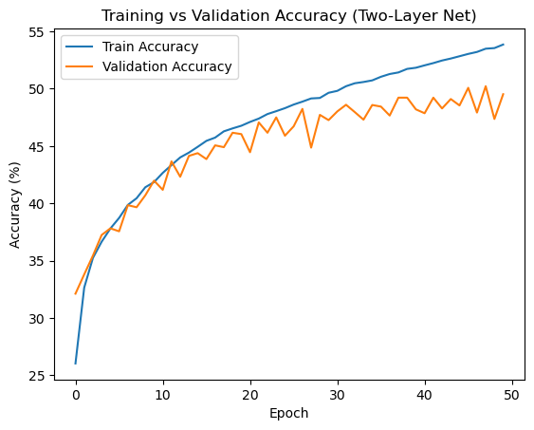

Retraining on train + validation...

Evaluating on test set...

==================================================
FINAL TEST ACCURACY: 50.76%
==================================================

Best hyper parameters and outputs for linear classifier
Chosen params: Batch size 128 learning_rate = 1e-2 weight_decay = 1e-2
Epoch 1/10, Train loss: 2.0041, Train acc: 28.82%, Val acc: 26.82%
Epoch 2/10, Train loss: 1.8746, Train acc: 34.83%, Val acc: 33.40%
Epoch 3/10, Train loss: 1.8394, Train acc: 36.13%, Val acc: 36.02%
Epoch 4/10, Train loss: 1.8174, Train acc: 36.87%, Val acc: 36.98%
Epoch 5/10, Train loss: 1.8037, Train acc: 37.46%, Val acc: 37.90%
Epoch 6/10, Train loss: 1.7942, Train acc: 37.81%, Val acc: 36.40%
Epoch 7/10, Train loss: 1.7847, Train acc: 38.52%, Val acc: 35.60%
Epoch 8/10, Train loss: 1.7778, Train acc: 38.64%, Val acc: 38.84%
Epoch 9/10, Train loss: 1.7719, Train acc: 38.99%, Val acc: 33.76%
Epoch 10/10, Train loss: 1.7693, Train acc: 39.04%, Val acc: 36.52%


Retraining on train + validation...

Final Test Accuracy: 37.91% pretty good for linear classifier

Best hyper parameters and outputs for 2 layer network
Batch 128, hidden dim 300, learning rate = 1e-2, weight decay = 1e-3, epoch 50
Epoch 1/50, Train loss: 2.1085, Train acc: 26.03%, Val acc: 32.12%
Epoch 2/50, Train loss: 1.9285, Train acc: 32.64%, Val acc: 33.80%
Epoch 3/50, Train loss: 1.8618, Train acc: 35.24%, Val acc: 35.44%
Epoch 4/50, Train loss: 1.8187, Train acc: 36.65%, Val acc: 37.24%
Epoch 5/50, Train loss: 1.7861, Train acc: 37.80%, Val acc: 37.82%
Epoch 6/50, Train loss: 1.7582, Train acc: 38.73%, Val acc: 37.56%
Epoch 7/50, Train loss: 1.7331, Train acc: 39.86%, Val acc: 39.84%
Epoch 8/50, Train loss: 1.7104, Train acc: 40.44%, Val acc: 39.66%
Epoch 9/50, Train loss: 1.6896, Train acc: 41.40%, Val acc: 40.70%
Epoch 10/50, Train loss: 1.6693, Train acc: 41.85%, Val acc: 41.98%
Epoch 11/50, Train loss: 1.6512, Train acc: 42.66%, Val acc: 41.18%
Epoch 12/50, Train loss: 1.6322, Train acc: 43.34%, Val acc: 43.66%
Epoch 13/50, Train loss: 1.6160, Train acc: 44.01%, Val acc: 42.32%
Epoch 14/50, Train loss: 1.6017, Train acc: 44.43%, Val acc: 44.14%
Epoch 15/50, Train loss: 1.5873, Train acc: 44.93%, Val acc: 44.38%
Epoch 16/50, Train loss: 1.5734, Train acc: 45.45%, Val acc: 43.86%
Epoch 17/50, Train loss: 1.5624, Train acc: 45.74%, Val acc: 45.06%
Epoch 18/50, Train loss: 1.5514, Train acc: 46.28%, Val acc: 44.90%
Epoch 19/50, Train loss: 1.5398, Train acc: 46.54%, Val acc: 46.16%
Epoch 20/50, Train loss: 1.5303, Train acc: 46.77%, Val acc: 46.04%
Epoch 21/50, Train loss: 1.5214, Train acc: 47.10%, Val acc: 44.46%
Epoch 22/50, Train loss: 1.5118, Train acc: 47.39%, Val acc: 47.06%
Epoch 23/50, Train loss: 1.5024, Train acc: 47.79%, Val acc: 46.16%
Epoch 24/50, Train loss: 1.4940, Train acc: 48.04%, Val acc: 47.50%
Epoch 25/50, Train loss: 1.4869, Train acc: 48.30%, Val acc: 45.90%
Epoch 26/50, Train loss: 1.4789, Train acc: 48.62%, Val acc: 46.72%
Epoch 27/50, Train loss: 1.4713, Train acc: 48.87%, Val acc: 48.24%
Epoch 28/50, Train loss: 1.4631, Train acc: 49.15%, Val acc: 44.86%
Epoch 29/50, Train loss: 1.4583, Train acc: 49.19%, Val acc: 47.72%
Epoch 30/50, Train loss: 1.4495, Train acc: 49.64%, Val acc: 47.26%
Epoch 31/50, Train loss: 1.4428, Train acc: 49.81%, Val acc: 48.02%
Epoch 32/50, Train loss: 1.4359, Train acc: 50.22%, Val acc: 48.60%
Epoch 33/50, Train loss: 1.4288, Train acc: 50.48%, Val acc: 47.96%
Epoch 34/50, Train loss: 1.4219, Train acc: 50.59%, Val acc: 47.30%
Epoch 35/50, Train loss: 1.4168, Train acc: 50.73%, Val acc: 48.58%
Epoch 36/50, Train loss: 1.4083, Train acc: 51.04%, Val acc: 48.44%
Epoch 37/50, Train loss: 1.4033, Train acc: 51.28%, Val acc: 47.66%
Epoch 38/50, Train loss: 1.3978, Train acc: 51.42%, Val acc: 49.22%
Epoch 39/50, Train loss: 1.3913, Train acc: 51.73%, Val acc: 49.22%
Epoch 40/50, Train loss: 1.3860, Train acc: 51.83%, Val acc: 48.20%
Epoch 41/50, Train loss: 1.3791, Train acc: 52.04%, Val acc: 47.86%
Epoch 42/50, Train loss: 1.3755, Train acc: 52.24%, Val acc: 49.22%
Epoch 43/50, Train loss: 1.3694, Train acc: 52.46%, Val acc: 48.28%
Epoch 44/50, Train loss: 1.3637, Train acc: 52.63%, Val acc: 49.10%
Epoch 45/50, Train loss: 1.3571, Train acc: 52.83%, Val acc: 48.54%
Epoch 46/50, Train loss: 1.3551, Train acc: 53.04%, Val acc: 50.08%
Epoch 47/50, Train loss: 1.3469, Train acc: 53.21%, Val acc: 47.92%
Epoch 48/50, Train loss: 1.3421, Train acc: 53.49%, Val acc: 50.22%
Epoch 49/50, Train loss: 1.3383, Train acc: 53.54%, Val acc: 47.36%
Epoch 50/50, Train loss: 1.3312, Train acc: 53.85%, Val acc: 49.52%


Retraining on train + validation...

Evaluating on test set...

==================================================
FINAL TEST ACCURACY: 50.76%
==================================================

Found that the learning and decay hyper parameters are about the same in both models but in the 2 layer model using the hidden dim and increasing the number of epochs allows the original parameters to continue to increase values therefore allowing the test accuracy to increase as well meaning a 20% increase in accuracy and by adding more layers im sure the accuracy could continue to go up but maybe not at such a tremendous rate

